CUSTOMER INFORMATION
Requested By: |  |  |  |  | Date:
Customer: |  |  |  |  | End User:
Contact: |  |  | Phone: |  |  |  |  | Email:
Program: |  |  |  |  | Plant:
Budgetary/Concept Only |  |  |  |  | Quantity:
APPLICATION INFORMATION
Geo model select Clinch/weld gun positioning
Other, describe:
For Part Presentation Slides – use Extrusion Slide Worksheet QPE-FM-007
Standard Part Number or slide series used as reference:
ORIENTATION WORK ENVELOPE (overall size not to exceed)
Angle A |  | 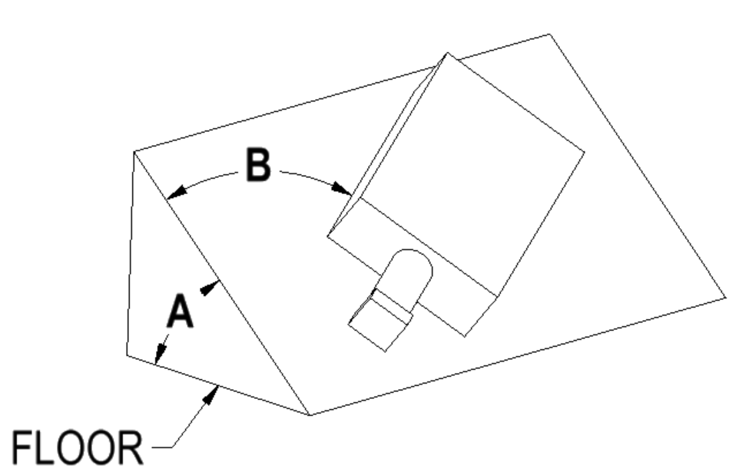 | Length (in travel direction), mm
 |  |  | Width, mm
Angle B |  |  | Height, mm
 |  |  | Welker choice
PLATEN SIZE
Length (in travel direction), mm |  |  | Width, mm
Welker choice | Drawing attached
LOAD
Payload |  |  | kg | Notes:
Location of c.g. relative the center of carriage (attach drawing if possible) |  |  |  |  |  |  | 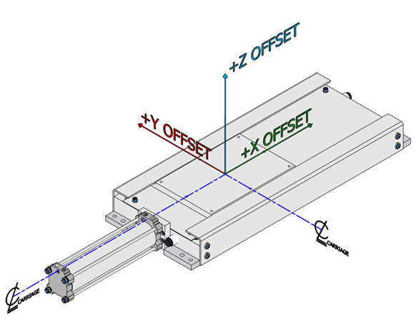
X offset, mm
Y offset, mm
Z offset, mm
Externally applied loads and direction of application:
OPERATION
Cycle Rate: |  | JPH cycles/min Other:
OPERATING ENVIRONMENT
Temperature Range: |  | Standard [32°F - 104°F(0°C - 40°C)] |  | Other:
Contamination: | Welding Machining Other:
TRAVEL
Overall travel: |  |  |  | mm |  | Number of working positions |  |  |  | Single 2-position Multiple
If multiple position, indicate stop points:
Note: Pneumatic actuated units will stroke to hard stops. Hard stops on electric actuated units are for homing or overtravel only. Unless otherwise specified, 5mm overtravel will be included in each direction on electric units.
 | Accuracy req’d: |  | Welker std. (see chart next page)
 |  |  | Other: |  | X±: |  |  | mm | Y±: |  | mm | Z±: |  | mm
 | Repeatability req’d: |  | Welker std. (see chart next page) |  |  |  |  |  | Other: |  |  | X±: |  | mm
One-way index time (electric only): |  |  |  |  |  |  |  |  | sec
ACTUATOR
Pneumatic, non-locking |  |  |  |  | Pneumatic, locking
Electric – VFD/induction |  |  |  |  | Electric - servo
Preferred manufacturer: |  |  |  |  | Welker choice
Electric – by customer. Provide motor mfr. and series/model number:
Motor voltage: |  |  | Brake voltage: | 120VAC 480VAC 575VAC Other
Homing pin (servo unit only) Unless otherwise specified, homing pin will be located 5mm from retract (drive end) hard stop.
Lockout (pneumatic/hydraulic only): None Pneumatic Manual, Tru-Lok Manual, Welker choice
SWITCHES
Welker choice Smart Stops Cylinder Switches Prox Other:
LUBRICATION
Zerk (standard) | Auto lube
BEARINGS/GUIDES (type & manufacturer)
Welker choice (standard) | Other, specify:
STANDARD TOLERANCES (see product catalog for details)
Pneumatic Rail Slides |  |  |  |  |  |  | Pneumatic Plain Bearing Slides
Series | Stroke Tolerance* |  | Travel Runout |  |  |  | Series |  | Stop Position Tolerance* |  | Travel Runout
 |  |  | Y |  | Z |  |  |  |  |  | Y | Z
LPM/LP1/LP2 | ±0.20mm |  | 0.15mm |  | 0.40mm |  | P5 |  | ±0.42mm |  | 0.45mm | 0.60mm
R2 |  |  |  |  |  |  | P7 |  | ±0.30mm |  | 0.53mm | 0.74mm
NL3/WL3
*Duplex mid-position stops ±0.80mm
Electric Slides
Actuator |  | Typical Stop Position Accuracy |  |  |  |  |  | Typical Stop Position Repeatability
 |  | Lead Screw |  | Ball Screw |  |  |  | Lead Screw |  | Ball Screw
VFD/Induction |  | ±1mm |  | N/A |  |  |  | ±1mm |  | N/A
Servo |  | ±0.08mm/100mm |  | ±0.06mm/100mm (standard)  ±0.03mm/100mm (precision) |  |  |  | ±0.4mm |  | ±0.10mm (standard)  ±0.05mm (precision)
SKETCH/NOTES (attach additional sheets as needed)

